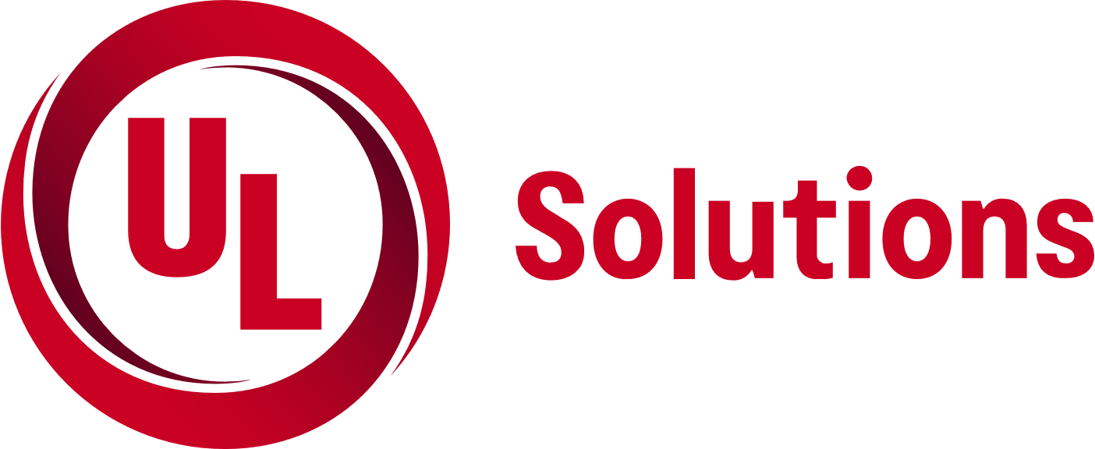
UL TOWN HALL PRESENTATION _________________________________________________________________________________________________________

‘Fire Alarm Compliance Methodologies and Emergency Responder Communication Enhancement Systems (ERCES)’
Hosted By
Lake Mary Fire Rescue Fire Prevention
Join us for a free educational and informational presentation addressing best practices for fire alarm systems, ERCES, and UL’s systematic follow up approach addressing code compliance within the built environment.
Program
This free presentation addresses various requirements, enforcement tools, and methodologies found within the framework of Florida State Fire and Building Codes, NFPA 72, and UL’s systematic fire alarm certification follow up program to confirm and verify initial and on-going compliance of fire alarm systems. This presentation also addresses requirements, enforcement tools, and methodologies found within the framework of the Florida State Fire Code, NFPA 1 11.10, and NFPA 1221/1225 regarding the verification of initial and on-going compliance for ERCES, the establishment of ERCES best management practices, and an introduction to UL 2524, 2021 Model Fire Code ERCES requirements, and the forthcoming UL ERCES Certification program.
Date / Time / Continuing Education Credits
Tuesday, April 2nd, 2024|830am – 1230pm|4 Hrs. CEUs upon request (ICC PPP and/or Florida Fire College)
(Coffee and snacks provided)
Location
Lake Mary Events Center
260 N. Country Club Road Lake Mary FL 32746
RSVP by Friday March 22nd, 2024 to
Link to register: https://app.smartsheet.com/b/form/5b26c3d03de94bd7bc07bc3691244b92
Presentation Topics
Fire Alarm Systems Compliance Methodologies:
      - NFPA 72 Chapter 14: Inspection, Testing and Maintenance
      - NFPA 72 Chapter 26: Supervising Stations Alarm Systems & UL’s Systematic Follow up of Compliance Fire Alarm Program
Emergency Responder Communication Enhancement Systems (ERCES):
- NFPA 1 Chapter 11.10
- NFPA 1221 (9.6/11.3.9): Standard for the Installation, Maintenance, and Use of Emergency Services Communications Systems, 2016 Edition
- NFPA 1225 Chapter 18/20: In-Building Emergency Responder Communications Enhancement Systems
- UL 2524: Standard for In-building 2-Way Emergency Radio Communication Enhancement Systems
- UL ERCES Certification Program
For more information about UL’s Alarm Certificate Services Program, visit:
UL.com/AlarmService / Emergency Responder Communications Enhancement Systems (ERCES) | UL Solutions

